PRINCIPLES OF FLIGHT(SD/SW)

MULTIPLE CHOICE QUESTIONS

1. The deviation of meanline from chord is known as-
(a)Cantilever (b) Bank (c) Camber (d) Chord line
2. Mass has energy if it has capacity to do.
(a)Storage (b) Pressure (c) Work (d) All of these
3. The small auxiliary aerofoils placed in front of the main aerofoil leading
edge with suitable gap or slot between.
(a) Slat mainly fixed, controlled, automatic (b) Slat mainly fixed, controlled
(c) Slat mainly fixed only (d) None of these
4. The line along which the chord is measured.
(a) Stringer (b) Spar (c) Chord line (d) Chord
5. The forward edge of an aerofoil surface is known as
(a)Trailing edge (b) Leading edge (c) Camber (d) Chord
6. The stall is a condition where in the AOA
(a) Increases (b) decreases (c) remains same (d) None of these
7. To every action, there is an equal and opposite reaction.
(a) Newton’s first law (b) Newton’s second law (c) Newton’s third law
8. The distance between leading edge to trailing edge is known as
(a) Stringer (b) Spar (c) Chord line (d) Chord
9. The vertical component of total reaction is called
(a) drag (b) weight (c) lift (d) thrust
10. The angle between chord line and the longitudinal axis of the aircraft is called
(a) AOA (b) Horizontal control (c) Angle of incidence (d) vertical angle
11. The density is
(a) mass per unit volume b) mass per unit area (c) force per unit area (d) mass per unit energy
12.

FILL IN THE BLANKS
- Angle between chord line and relative air flow known as (Angle of attack)
- The distance between leading edge to trailing edge is known as (Chord)
- The vertical component of total reaction is called _________________(lift)
- the angle beween chord line and the longitudianal axis of the aircraftis called_____(angle of incidence)
- __________is force per unit area (pressure)
- The density is (Mass per unit volume
- There are four forces acting on aircraft (Lift, Drag, Weight, Thrust)
- In the case of aircraft CG stands for (Center of Gravity)
- .Rate of change of position is called_____________________________(speed)
- The force which tends to move the aircraft to the rearward is _______(drag)

TRUE&FALSE
- The pressure and density decreases with altitude. True
- The atmosphere temperature increases when altitudes increases. False
- Density is mass per unit volume. True
- Aerofoil is designed to produce more drag than lift. False
- Velocity is speed in particular direction. True
- CG means centre of gravity. True
- .Speed is rate of change of position. True
- Chord length is the length of aircraft. False
- Acceleration is the rate of change of velocity. True
- To every action, there is an equal and opposite reaction. True
- Work = Force x Distance True
- The sum total of all energy in the universe remains constant. True
- Angle of attack is the angle between the chord line and the relative air flow. True
- Lift is the vertical component of Total Reaction True
- Drag is the resistance of the air to anything moving through it. True
- At the 15degree (approx) angle of attack is maximum lift beyond this angle
it decreases very rapidly. True
17. The pressure drop on top of aerofoil and maximum pressure increases under
the bottom aerofoil surface is near the point of maximum camber. True

SA-1 (02marks)
Q.1- Explain Angle of attack.
ANGLE OF ATTACK:
The path of the propeller through the air determines the direction of the relative airflow. The angle between the blade chord and the relative airflow is the angle of attack. The angle of attack is the result of propeller rotational velocity (RPM) and aircraft forward velocity (TAS).

Q-2: Define the following.
(a)Density(b)Motion (c)Speed (d)Velocity (e) Acceleration
(a)Density It is the mass per unit volume.
(b)Motion Motion is said to be there when a body changes its position in relation to its surroundings.
(c)Speed : Speed is the rate of change of position.
(d)Velocity Velocity is speed in particular direction. Velocity is a vector quantity having both magnitude and direction.
(e) Acceleration Acceleration is the rate of change of velocity. The change may be in magnitude or direction or in both. Thus a body moving along a circular path at constant speed has acceleration.
Force
Acceleration =
Mass

Q-2.Explain Newton,s First Law of Motion.
First Law of Motion: A body will continue to be in state of rest or of uniform motion in a straight line unless acted upon by an external force. This property of all bodies is called inertia and a body in such a state is said to be in Equilibrium.
Q-3 Explain Newton,s Second Law of Motion.
Newton’s Second Law of Motion: The rate of change of momentum of a body is directly proportional to the applied force and takes place in the direction of the application of the said force.
Q.4 Explain Newton,s Third Law of Motion.
Newton’s Third Law of Motion: To every action, there is an equal and opposite reaction.

LA-1 (03marks)

Q-1: Define the following.
(a)Force(b)Weight (c)Work (d)Power (e)Energy (f)Pressure(g)Momentum (h)Centre of gravity(j) Kinetic Energy
(a)Force Unit - Newton (N) -‘A push or a pull’. That which causes or tends to cause a change in motion of a body.
(b)Weight (a) The earth exerts a certain force towards its centre on all objects on its surface. This force is called Weight of the body and is equal to the mass of the body multiplied by the acceleration due to gravity ‘g’.Unit - Newton (N) - ‘The force due to gravity’. (F = m x g)

(a) The earth exerts a certain force towards its centre on all objects on its surface. This force is called Weight of the body and is equal to the mass of the body multiplied by the acceleration due to gravity ‘g’.Unit - Newton (N) - ‘The force due to gravity’. (F = m x g)

(c)Work Unit - Joule (J) - A force is said to do work on a body when it moves the body in the direction in which the force is acting. The amount of work done on a body is the product of the force applied to the body and the distance moved by that force in the direction in which it is acting. If a force is exerted and no movement takes place, no work has been done.
e.g. (a) Work = Force x Distance (through which the force is applied)
. (d)Power Unit - Watt (W) - Power is simply the rate of doing work, (the time taken to do work)
Force (N) x Distance (m)
e.g. (a) Power (W) =
Time (s)
(e)Energy Unit - Joule (J) - Mass has energy if it has the ability to do work. The amount of energy a body possesses is measured by the amount of work it can do. The unit of energy will therefore be the same as those of work, joules.
(f)Pressure Pressure is force per unit area Kinetic Energy: Unit - Joule (J) - ‘The energy possessed by mass because of its motion’. ‘A mass that is moving can do work in coming to rest’.

KE = ¹/2 m V² joules
(g)Momentum Unit - Mass x Velocity (kg-m/s) - ‘The quantity of motion possessed by a body’. The tendency of a body to continue in motion after being placed in motion.

(h)Centre of gravity (CG): The point through which the weight of an aircraft acts.
- An aircraft in flight is said to rotate around its CG.
- The CG of an aircraft must remain within certain forward and aft limits, for reasons of both stability and control

(j) Kinetic Energy Unit - Joule (J) - ‘The energy possessed by mass because of its motion’. ‘A mass that is moving can do work in coming to rest’.

KE = ¹/2 m V² joules

Q-2: Define the following.
(a)Aerofoil (b)Chord line (c)Chord length (d)Angle of attack (e)Angle of incidence (f)Total reaction (g)Lift (h)Drag

- Aerofoil: A body designed to produce more lift than drag. A typical aerofoil section is cambered on top surface and is more or less straight at bottom.
- Chord line: It is a line joining the centres of curvature of leading and trailing edges of an aerofoil section
- Chord length: It is the length of chord line intercepted between the leading and trailing edges.
- Angle of attack: It is the angle between the chord line and the relative air flow undisturbed by the presence of aerofoil.
- Angle of incidence: The angle between the chord line and the longitudinal axis of the aircraft.
- Total Reaction: It is one single force representing all the pressures (force per What is meant by unit area) over the surface of the aerofoil. It acts through the centre of pressure which is situated on the chord line.
- Lift: The vertical component of Total Reaction, resolved at right angles to the relative airflow.
- Drag: The horizontal component of the Total Reaction acting angles and in the same direction as the relative airflow.

Q.2 Define the following
(a)Thrust (b) Propeller
- Thrust is a reaction force described quantitatively by Newton's second and third laws. When a system expels or accelerates mass in one direction, the accelerated mass will cause a force of equal magnitude but opposite direction on that system. The force applied on a surface in a direction perpendicular or normal to the surface is called thrust.
- Propeller :- A propeller converts shaft power from the engine into thrust. It does this by accelerating a mass of air rearwards. Thrust from the propeller is equal to the mass of air accelerated rearwards multiplied by the acceleration given to it. A mass is accelerated rearwards and the equal and opposite reaction drives the aircraft forwards

Q.3 Explain Bernauli’s Principle.
Ans:-Bernoulli's principle states that for an inviscid flow, an increase in the speed of the fluid occurs simultaneously with a decrease in pressure or a decrease in the fluid's potential energy
Q.4 Describe aerofoil.
Aerofoil is the shape of a wing or blade (of a propeller, rotor or turbine) or sail as seen in cross-section.
An airfoil-shaped body moved through a fluid produces an aerodynamic force. The component of this force perpendicular to the direction of motion is called lift. The component parallel to the direction of motion is called drag. Subsonic flight airfoils have a characteristic shape with a rounded leading edge, followed by a sharp trailing edge, often with asymmetric camber. Foils of similar function designed with water as the working fluid are called hydrofoils.
Q-5.What do you mean byTotal reaction?

Total Reaction: It is one single force representing all the pressures (force per unit area) over the surface of the aerofoil. It acts through the centre of pressure which is situated on the chord line.

LA-2 (04marks)
Q.1 What is meant by ventury effect? .
Ans:- Venturi Effect: At low flight speeds, air experiences relatively small changes in pressure and negligable changes in density. This airflow is termed incompressable since the air may undergo changes in pressure without apparent changes in density. Such airflow is similar to the flow of water, hydraulic fluid, or any other incompressable fluid. This suggests that between any two points in the tube, the velocity varies inversely with the area. Venturi effect is the name used to describe this phenomenon. Fluid flow speeds up through the restricted area of a venturi in direct proportion to the reduction in area. The Figure below suggests what happens to the speed of the flow through the tube discussed.

Q.2 What do you mean by stall?
A stall is a reduction in the lift coefficient generated by a foil as angle of attack increases. This occurs when the critical angle of attack of the foil is exceeded. The critical angle of attack is typically about 15 degrees, but it may vary significantly depending on the fluid, foil, and Reynolds number.
Stalls in fixed-wing flight are often experienced as a sudden reduction in lift as the pilot increases angle of attack and exceeds the critical angle of attack (which may be due to slowing down below stall speed in level flight). A stall does not mean that the engine(s) have stopped working, or that the aircraft has stopped moving — the effect is the same even in an unpowered glider aircraft.
Q.3 Explain venture effect’
. Venturi Effect: At low flight speeds, air experiences relatively small changes in pressure and negligable changes in density. This airflow is termed incompressable since the air may undergo changes in pressure without apparent changes in density. Such airflow is similar to the flow of water, hydraulic fluid, or any other incompressable fluid. This suggests that between any two points in the tube, the velocity varies inversely with the area. Venturi effect is the name used to describe this phenomenon. Fluid flow speeds up through the restricted area of a venturi in direct proportion to the reduction in area. The Figure below suggests what happens to the speed of the flow through the tube discussed.

ESSAY TYPE (06marks)

Q.1 What are the forces acting on the aircraft?
FORCES ATCING ON AIRCRAFT
- Lift is a positive force caused by the difference in air pressure under and above a wing. The higher air pressure beneath a wing creates lift, and is affected by the shape of the wing. Changing a wing's angle of attack affects the speed of the air flowing over the wing and the amount of lift that the wing creates.
- Weightis the force that causes objects to fall downwards. In flight, the force of weight is countered by the forces of lift and thrust.
- Thrust is the force that propels an object forward. An engine spinning a propeller or a jet engine expelling hot air out the tailpipe are examples of thrust. In bats, thrust is created by muscles making the wings flap.
- Drag is the resistance of the air to anything moving through it. Different wing shapes greatly affect drag. Air divides smoothly around a wing's rounded leading edge, and flows neatly off its tapered trailing edge...this is called streamlining.

Q.2 Define flap and slat.
Flaps are hinged surfaces mounted on the trailing edges of the wings of a fixed-wing aircraft to reduce the speed at which an aircraft can be safely flown and to increase the angle of descent for landing. They shorten takeoff and landing distances. Flaps do this by lowering the stall speed and increasing the drag.
Slats are aerodynamic surfaces on the leading edge of the wings of fixed-wing aircraft which, when deployed, allow the wing to operate at a higher angle of attack. A higher coefficient of lift is produced as a result of angle of attack and speed, so by deploying slats an aircraft can fly at slower speeds, or take off and land in shorter distances. They are usually used while landing or performing maneuvers which take the aircraft close to the stall, but are usually retracted in normal flight to minimize drag.
Q.3-Name various types of aerofoils.
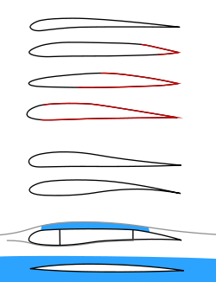
• Laminar flow airfoil for a RC park flyer
• Laminar flow airfoil for a RC pylon racer
• Laminar flow airfoil for a manned propeller aircraft
• Laminar flow at a jet airliner airfoil
• Stable airfoil used for flying wings
• Aft loaded airfoil allowing for a large main spar and late stall
• Transonic supercritical airfoil
• Supersonic leading edge airfoil
Colors:
Black = laminar flow,
red = turbulent flow,
grey = subsonic stream,
blue = supersonic flow volume

PF-6
Q.4-What are the forces acting on aircraft during flight.
FORCES ATCING ON AIRCRAFT
- Lift is a positive force caused by the difference in air pressure under and above a wing. The higher air pressure beneath a wing creates lift, and is affected by the shape of the wing. Changing a wing's angle of attack affects the speed of the air flowing over the wing and the amount of lift that the wing creates.
- Weightis the force that causes objects to fall downwards. In flight, the force of weight is countered by the forces of lift and thrust.
- Thrust is the force that propels an object forward. An engine spinning a propeller or a jet engine expelling hot air out the tailpipe are examples of thrust. In bats, thrust is created by muscles making the wings flap.
- Drag is the resistance of the air to anything moving through it. Different wing shapes greatly affect drag. Air divides smoothly around a wing's rounded leading edge, and flows neatly off its tapered trailing edge...this is called streamlining.

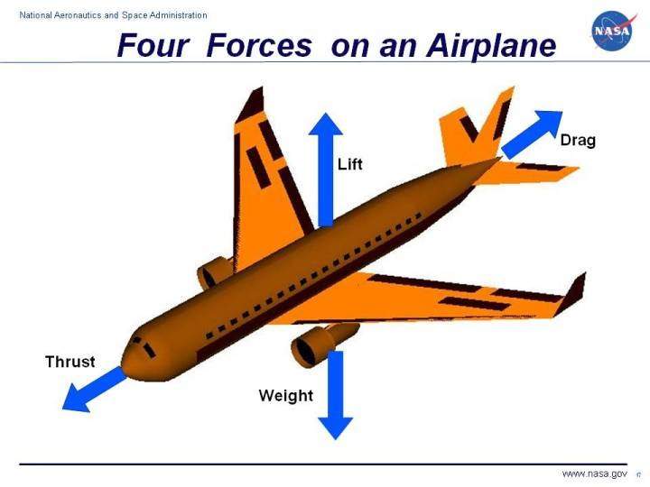
-

Q.5-Explain lift &drag.
Lift is a positive force caused by the difference in air pressure under and above a wing. The higher air pressure beneath a wing creates lift, and is affected by the shape of the wing. Changing a wing's angle of attack affects the speed of the air flowing over the wing and the amount of lift that the wing creates. The lift forces act vertically up 90⁰ to the direct of flight.
Drag is the resistance of the air to anything moving through it. Different wing shapes greatly affect drag. Air divides smoothly around a wing's rounded leading edge, and flows neatly off its tapered trailing edge this is called streamlining. Drag forces act parallel and opposite to the direction of flight.
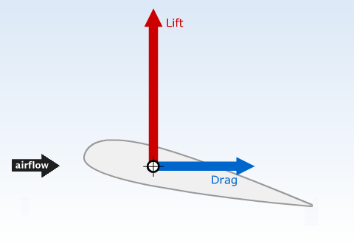

PF-8
Q.6-Name various types of flaps
Types of Flaps:
- Plain flap: the rear portion of airfoil rotates downwards on a simple hinge mounted at the front of the flap. Due to the greater efficiency of other flap types, the plain flap is normally only used where simplicity is required. A modern variation on the plain flap exploits the ability of composites to be designed to be rigid in one direction, while flexible in another. When such a material forms the skin of the wing, its camber can be altered by the geometry of the internal supporting structure, allowing such a surface to be used either as a flap or as an aileron.
- Split flap: the rear portion of the lower surface of the airfoil hinges downwards from the leading edge of the flap, while the upper surface stays immobile. Like the plain flap, this can cause large changes in longitudinal trim, pitching the nose either down or up, and tends to produce more drag than lift. At full deflection, a split flaps acts much like a spoiler, producing lots of drag and little or no lift.
- Slotted flap: a gap between the flap and the wing forces high pressure air from below the wing over the flap helping the airflow remain attached to the flap, increasing lift compared to a split flap. Additionally, lift across the entire chord of the primary airfoil is greatly increased as the velocity of air leaving its trailing edge is raised, from the typical non-flap 80% of freestream, to that of the higher-speed, lower-pressure air flowing around the leading edge of the slotted flap. Any flap that allows air to pass between the wing and the flap is considered a slotted flap.
- Fowler flap: split flap that slides backwards flat, before hinging downwards, thereby increasing first chord, then camber. The flap may form part of the uppersurface of the wing, like a plain flap, or it may not, like a split flap but it must slide rearward before lowering. It may provide some slot effect but this is not a defining feature of the type.
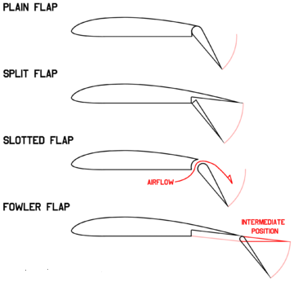

Q.7-Name varioustypes of slats.
Types of Slats:
- Automatic - the slat lies flush with the wing leading edge until reduced aerodynamic forces allow it to extend by way of aerodynamics when needed. Sometimes referred to as Handley-Page slats.
- Fixed - the slat is permanently extended. This is sometimes used on specialist low-speed aircraft (these are referred to as slots) or when simplicity takes precedence over speed.
- Powered - the slat extension can be controlled by the pilot. This is commonly used on airliners.
Q.8-What is stalling speed.
Stalling Speed: Stalls depend only on angle of attack, not airspeed. Because a correlation with airspeed exists, however, a "stall speed" is usually used in practice. It is the speed below which the airplane cannot create enough lift to sustain its weight in 1g flight. In steady, unaccelerated (1g) flight, the faster an airplane goes, the less angle of attack it needs to hold the airplane up (i.e., to produce lift equal to weight). As the airplane slows down, it must increase angle of attack to create the same lift (equal to weight). As the speed slows further, at some point the angle of attack will be equal to the critical (stall) angle of attack. This speed is called the "stall speed". The angle of attack cannot be increased to get more lift at this point and so slowing below the stall speed will result in a descent. And, so, airspeed is often used as an indirect indicator of approaching stall conditions. The stall speed will vary depending on the airplane's weight, altitude, and configuration (flap setting, etc.)

